# Tables in html

On a web page, tables are made using the HTML **<table>** element. To make data easier for people to understand and engage with, tables are used to organize and present data in an organized grid format.

## Basic Layout

The **<table>** tag is used to specify the table element. The three main parts of the "<table>" are typically the **"<thead>", "<tbody>",** and **"<tfoot>"** which help organize the table's contents.

**<thead>:** The table's header row or rows, usually with column labels.

**<tbody>:**The table's primary data rows are contained in the <tbody> tag

**<tfoot>:**The table's footer row(s), which are typically used for totals or summaries, are contained in the <tfoot> element.

<table>

<thead>

<!-- table header content goes here -->

</thead>

<tbody>

<!-- table body content goes here -->

</tbody>

<tfoot>

<!-- table footer content goes here -->

</tfoot>

</table>

## Creating Rows and Columns

The **<tr>** (table row) element is used to define the rows within the table. Each row has cells that are specified using the **<td>** (table data) or **<th>** (table header) elements, respectively, for data cells and header cells.

**<tr>:** A table row;includes a group of table cells.

**<th>:** Cell in the table header;typically located in the <thead>. It serves as a column header and is by default shown in bold.

**<td>:** A table data cell; contained in the <tbody> and <tfoot>. It includes reliable information.

**NOTE:** Using the align attribute on the th or td elements, you can modify how a table's cells are aligned; typical values are "left," "center," and "right."

Here is a basic example of a table:

<table>

<thead>

<tr>

<th>NAME</th>

<th>AGE</th>

</tr>

</thead>

<tbody>

<tr>

<td>Alice</td>

<td>22</td>

</tr>

<tr>

<td>Bob</td>

<td>25</td>

</tr>

<tr>

<td>Dane</td>

<td>23</td>

</tr>

</tbody>

<tfoot>

<tr>

<td>total entries:</td>

<td>3</td>

</tr>

</tfoot>

</table>

**Output :**

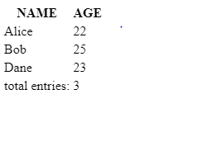

## Spanning Columns and Rows

**<rowspan>:** This specifies how many rows a cell should span in a <td> or <th>.

Example:

<table style="border:4px solid black;">

<tr>

<td>A</td>

<td rowspan="2">B (spans 2 rows)</td>

<td>C</td>

</tr>

<tr>

<td>D</td>

<td>E</td>

</tr>

<tr>

<td>F</td>

<td>G</td>

<td>H</td>

</tr>

</table>

**Output:**

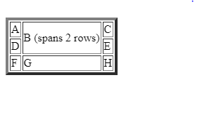

**<colspan>:** This specifies how many columns a cell should span in a <td> or <th>.

Example:

<table style="border:4px solid black;">

<tr>

<td colspan="2">Cell 1 ( Span 2 columns)</td>

<td>Cell 2</td>

</tr>

<tr>

<td>Cell 3</td>

<td>Cell 4</td>

<td>Cell 5</td>

</tr>

</table>

**Output:**

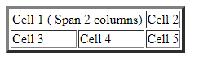

Lets see an example of colspan and rowspan in a single table:

<table border="2">

<tr>

<td rowspan="2"> 1 </td>

<td colspan="2"> 2 </td>

</tr>

<tr>

<td> 3 </td>

<td> 4 </td>

</tr>

</table>

**Output** :



## Table Attributes / Styling Tables

* **Border:** Defines the size of the table's outer border. It is employed to regulate the table's outward look. However, CSS is typically preferred for styling.

Use the CSS **“border”** property on **<table>, <th>**, and **<td>**  components to add a border:

With the “**border-style”** property, you can set the appearance of the border.

The following values are allowed:

* dotted
* dashed
* solid
* double
* groove
* ridge
* inset
* outset
* none
* hidden

Also by assigning the **“border-radius”** property, the borders get rounded corners and you can also set the color of the border using the property **“border-color”**.

**Collapsed-border:** Set the CSS **“border-collapse”** property to **“collapse”** to stop double borders from appearing in tables.The borders will merge into one border as a result.

Let us consider an example:

<html>

<head>

<style>

table, th, td {

border: 2px solid black;

border-radius: 10px;

text-align:center;

}

</style>

</head>

<body>

<table style="width:100%;height:50%;">

<thead>

<tr>

<th>NAME</th>

<th>AGE</th>

</tr>

</thead>

<tbody>

<tr>

<td>Alice</td>

<td>22</td>

</tr>

<tr>

<td>Bob</td>

<td>25</td>

</tr>

<tr>

<td>Dane</td>

<td>23</td>

</tr>

</tbody>

<tfoot>

<tr>

<td>total entries:</td>

<td>3</td>

</tr>

</tfoot>

</table>

</body>

</html>

**Output:**

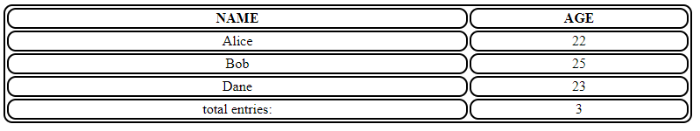

* **Width and Height:** Determine the table's width and height.
* **Summary:** To make the table's material more accessible, provide a summary or description.
* **Captions:** Using the <caption> element, a table caption can be added. Tables typically have captions at the top that provide a succinct title or description.
* **Cellspacing:** Defines the distance between cells by using the property **“border-spacing”**.
* **Cellpadding:** The distance between a cell's content and boundaries is specified by the cellpadding property.

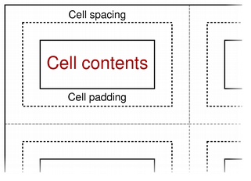

Let us see an example of cell spacing and padding:

<html>

<head>

<style>

table, th, td {

border: 2px dashed black;

padding:10px;

text-align:center;

}

table {

border-spacing: 30px;

}

</style>

</head>

<body>

<table >

<caption> Student List </caption>

<thead>

<tr>

<th>NAME</th>

<th>AGE</th>

</tr>

</thead>

<tbody>

<tr>

<td>Alice</td>

<td>22</td>

</tr>

<tr>

<td>Bob</td>

<td>25</td>

</tr>

<tr>

<td>Dane</td>

<td>23</td>

</tr>

</tbody>

<tfoot>

<tr>

<td>total entries:</td>

<td>3</td>

</tr>

</tfoot>

</table>

</body>

</html>

**Output:**

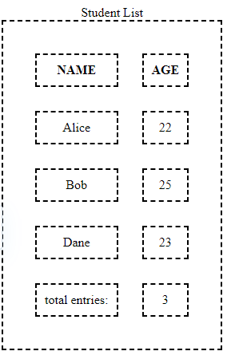

## Colgroup

To design or provide a group of table columns common properties, use the HTML <colgroup> element inside a <table> element. To declare the properties for the columns, it is often used along with the <col> element.

**<colgroup>:** It allows you to group columns and apply styling or attributes to those columns collectively.

**<col>:** The **<col>** element is used within a **<colgroup>** to define properties or attributes for one or more columns.

**Span:** The span attribute specifies how many columns that get the style.

Let us consider an example of colgroup:

<html>

<body>

<table>

<caption>Exam Schedule</caption>

<colgroup>

<col span="2" style="background-color: lightgray;">

<col span="2" style="background-color: lightblue;">

</colgroup>

<tbody>

<tr>

<th>Subject</th>

<th>Day</th>

<th>Date</th>

<th>Time</th>

</tr>

<tr>

<td>Maths</td>

<td>Mon</td>

<td>15/10/23</td>

<td>10:00 A.M</td>

</tr>

<tr>

<td>English</td>

<td>TUE</td>

<td>16/10/23</td>

<td>10:00 A.M</td>

</tr>

<tr>

<td>Science</td>

<td>Wed</td>

<td>17/10/23</td>

<td>10:00 A.M</td>

</tr>

</tbody>

</table>

</body>

</html>

Output:

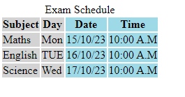

**Note:** The colgroup only permits the usage of a very small number of CSS properties, which includes background, Visibility, width and border properties.The tables you create will not be affected by any other CSS settings.

The HTML <table> element is a versatile tool for organizing and displaying information on web pages. To make tables that are both aesthetically pleasing and easily accessible, it's crucial to use it carefully and apply the proper styling. In order to build sophisticated and user-friendly layouts, modern web design frequently integrates HTML tables with CSS and other HTML components.